Temperature: Understanding Temperature Activity

Introduction


This activity uses a story about Max, a young boy learning about hot, cold, and "just right" temperatures on his family farm, to teach children temperature concepts and safety.

Storytelling and familiar examples help make these ideas clear and relevant for young learners.

While there is no direct interaction with MMS or feedback, this activity shows how the device can deliver consistent educational content.

Educational Benefits

Experiential Learning Approach

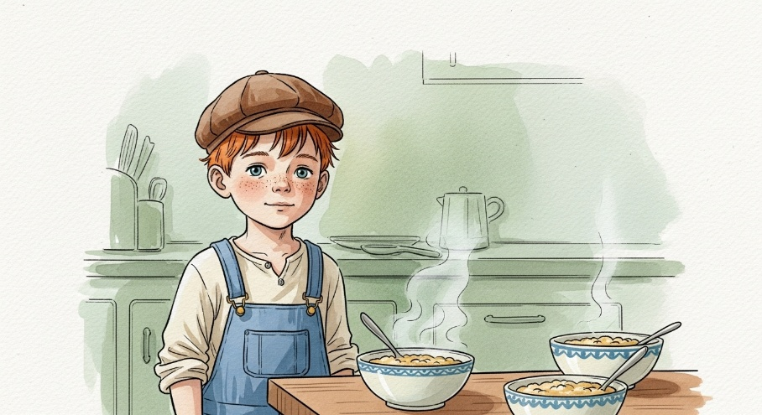
The story demonstrates temperature concepts through direct sensory experiences rather than abstract explanations. Children learn by observing steam from hot porridge, feeling the sting of cold surfaces, and experiencing the comfort of "just right" temperatures. This multi-sensory approach reinforces learning and makes concepts more memorable.

Safety-First Methodology

Rather than simply explaining temperature as a scientific concept, the narrative prioritizes safety awareness. Children learn to identify warning signs like steam, understand the consequences of extreme temperatures, and develop protective behaviours before encountering potentially dangerous situations.

Progressive Complexity

The lesson begins with simple comparisons (hot, cold, just right) and gradually introduces more sophisticated concepts like thermometers, degrees Celsius, and specific temperature ranges. This scaffolded approach ensures children can build understanding incrementally without becoming overwhelmed.

Real-World Applications


The content connects temperature awareness to practical daily activities such as bath time, outdoor play, and food safety. This approach helps children transfer learning from the educational context to their actual lived experiences.

Intended Learning Outcomes for Children

Core Temperature Concepts

Children will develop fundamental understanding that temperature describes how hot or cold something is, and that extreme temperatures can be harmful. They will learn to recognize visual and tactile cues that indicate temperature levels, such as steam indicating heat and the physical sensation of cold surfaces.

Safety Awareness and Prevention

Children will acquire essential safety skills including asking adults before touching unknown objects, recognizing warning signs of dangerous temperatures, and understanding appropriate responses to temperature-related discomfort. The content emphasizes prevention rather than reaction, building proactive safety habits.


Body Awareness and Self-Monitoring

Children will learn to recognize their body's natural responses to temperature extremes, including sweating, dizziness, and shivering. They will understand these as important communication signals and learn appropriate responses such as seeking shade, drinking water, or adding clothing layers.

Tool Recognition and Measurement

The narrative introduces thermometers as measurement tools and basic concepts about degrees and temperature scales. While age-appropriate, this foundation prepares children for more advanced scientific learning about measurement and numerical representation of physical phenomena.

Environmental Adaptation

Children will develop strategies for adapting to different temperature conditions through appropriate clothing choices, behavioural modifications, and environmental awareness during seasonal changes and various weather conditions.

Conclusion

This temperature education narrative provides a comprehensive foundation for teaching young children essential safety concepts while building scientific understanding. The story-based approach makes learning engaging and memorable while prioritizing practical safety skills that children can immediately apply in their daily lives.

The content successfully balances educational rigor with age-appropriate presentation, ensuring that complex concepts become accessible without losing their importance. By emphasizing experiential learning, safety awareness, and real-world application, this educational approach prepares children to navigate temperature-related situations confidently and safely.

The ultimate goal extends beyond mere temperature awareness to developing critical thinking skills, body awareness, and safety consciousness that will serve children throughout their lives as they encounter increasingly complex environmental challenges and decision-making situations.

