Memory: Memory Retention Activity

Introduction
Welcome to Memory, an interactive and educational exercise developed to assist children in assessing and improving their memorisation and recall abilities. This activity offers a structured environment where young learners can develop their memory skills through observation and practical engagement.

Objectives
- Develop the ability to memorise sequences of shapes, patterns, or items presented during the activity.
- Strengthen short-term and working memory by practising the recall of information in the correct order.
- Improve attention to detail and concentration, supporting accurate recollection of observed sequences.
- Foster strategies for effective memorisation and recall, such as grouping or repetition.

Activity Overview
The main lesson for children in the video is that remembering isn't just about being perfect; it's about trying your best and having fun while learning. Luna, the curious little fox, learns this important lesson as she completes memory challenges in the magical memory palace. She discovers that everyone's memory works differently, and that's what makes each person special. The video encourages children to enjoy the process of learning and to celebrate their unique abilities.

Benefits
Here are the benefits for children from the video:
- Encourages Learning: The video emphasizes that learning can be fun and enjoyable, motivating children to engage in educational activities.
- Promotes Effort: It teaches children that trying their best is more important than being perfect, fostering a growth mindset.
- Celebrates Uniqueness: The video highlights that everyone's memory works differently, helping children appreciate their unique abilities.
- Builds Confidence: By completing challenges, children gain confidence in their ability to remember and learn new things.
- Interactive Participation: The video involves children in the story, making learning interactive and engaging.
- Positive Reinforcement: It rewards effort and success, encouraging children to keep trying and learning.

Activity consists of:
The use of the buttons on the MMS and the use of the accelerometer sensors on the MMS.
Time Code | Objective | Action to take | Correct action | Clip from video
1:20 | Touch the circle button if no help needed. Touch the square button if they believe Luna needs help. | Press the circle or square button depending how confidant they feel. | No correct answer but can give an indication on confidence | 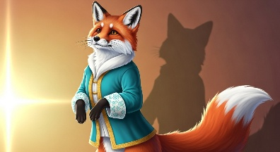
1:23 | Is the first colour in the sequence of 4 crystals red. | Press the circle if correct and the triangle if incorrect. | The first colour in the sequence is indeed red. | 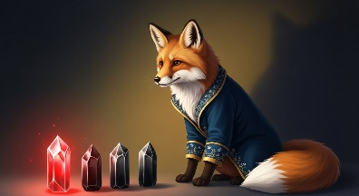
1:29 | Is the second colour in the sequence of 4 crystals green. | Press the circle if correct and the triangle if incorrect. | The second colour in the sequence is not green. It is blue. | 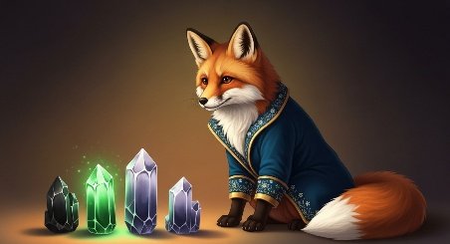
1:37 | Is the third colour in the sequence of 4 crystals blue. | Press the circle if correct and the triangle if incorrect. | The third colour in the sequence is not blue. It is green. | 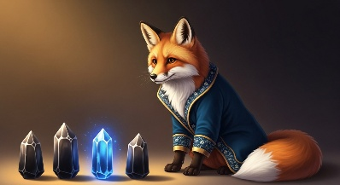
1:47 | Is the last colour in the sequence of 4 crystals yellow. | Press the circle if correct and the triangle if incorrect. | The fourth colour in the sequence is yellow. | 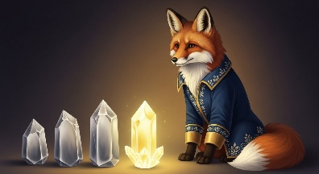
2:28 | Did Luna meet a bear named Benny? | Shake MMS up and down if true. Side to side if false. | Shake up and down as Luna did meet a bear named Benny.* | 
2:33 | Was Sally collecting berries? | Shake MMS up and down if true. Side to side if false. | Shake left and right as Sally was collecting acorns.* | 
2:38 | Was Oliver reading a book? | Shake MMS up and down if true. Side to side if false. | Shake up and down as Oliver was indeed reading a book.* | 
3:10 | Touch the stones in order of triangle, circle, square triangle. | Touch the button that represents the first touched stone. | The correct first stone is the triangle stone | 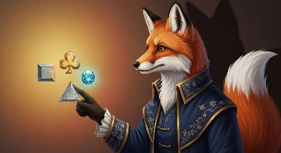
3:19 | Touch the stones in order of triangle, circle, square triangle. | Touch the button that represents the second touched stone. | The correct second stone is the circle stone | 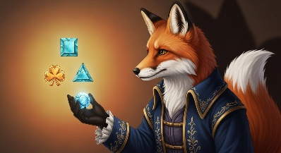
3:24 | Touch the stones in order of triangle, circle, square triangle. | Touch the button that represents the third touched stone. | The correct third stone is the square stone | 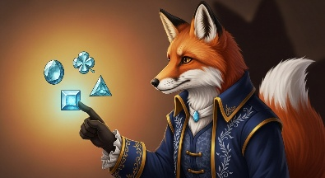
3:30 | Touch the stones in order of triangle, circle, square triangle. | Touch the button that represents the fourth touched stone. | The correct fourth stone is the triangle stone | 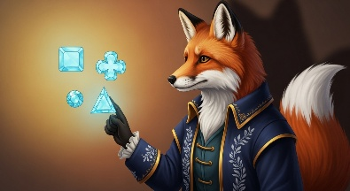
3:51 | Hold up MMS to celebrate | Hold up MMS | Hold the MMS up high.* | 
4:23 | Touch any button send good wishes | Touch any button | Correct to touch any button. | 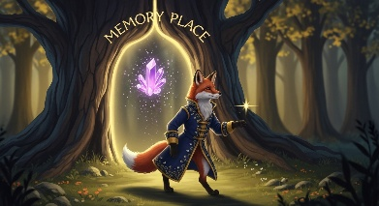
*The results will be presented as a plot. The Y-axis of the plot should display a deflection at the designated time code.
Young children should be able to remember basic sequences and follow basic instructions.

Conclusion
In conclusion, the story of Luna and the Memory Palace teaches children valuable lessons about the importance of effort, learning, and celebrating individual uniqueness. Through engaging challenges and interactive participation, children are encouraged to try their best, enjoy the learning process, and appreciate their unique abilities. The magical journey of Luna not only builds confidence but also reinforces the idea that everyone has their own special way of remembering and learning. This delightful adventure leaves children with a positive and empowering message that trying and having fun while learning is what truly matters.

