Colours: Colour recognising and colour separation Activity

Introduction

Hello everyone! Welcome to our fun and colourful show. Today, we have our friends Babloo and Droplet joining us. They have some exciting activities planned for you. Babloo and Droplet will be playing with colours, and you can join in too! They'll show you different colours, and if you have a magic monkey stick, you can hold it up when you see the same colour. Let's get started and have some fun with colours! Are you ready? Let's go!

Objectives
The main objective is to assess whether the children can identify various colours. Additionally, there is a section designed to evaluate potential colour vision impairment. This information may influence their learning process.

Activity Overview
This activity uses the MMS device’s light-changing feature to test if kids can identify colours by holding up the device. It also displays a multicoloured sign with an embedded arrow, asking kids to indicate the arrow's direction; missing the arrow may indicate vision impairment.

Benefits
Here are the benefits for children from the video:
- Colour Recognition: Helps children learn and identify different colours, enhancing their visual perception and cognitive skills.
- Attention to Detail: Encourages kids to pay close attention to the colours and details in the signs, improving their observation skills.
- Hand-Eye Coordination: Holding up the magic monkey sticks when they see the correct colour helps develop their hand-eye coordination.
- Following Instructions: Teaches children to listen carefully and follow instructions, which is an important skill for learning and development.
- Interactive Learning: Makes learning fun and interactive, keeping children engaged and motivated.
- Critical Thinking: Identifying the embedded arrow in the signs requires kids to think critically and make connections between what they see and what they need to do.
- Confidence Building: Successfully identifying colours and arrows can boost children's confidence and encourage them to participate in more learning activities.
- Social Interaction: If done in a group setting, this activity can promote social interaction and teamwork among children.
- These benefits may support the overall development of children, particularly during early childhood, in an engaging manner.

Activity consists of:
The use of the buttons on the MMS and the use of the accelerometer sensors on the MMS.
Time Code | Objective | Action to take | Correct action | Clip from video
2:03 | If the colour displayed is the same as the light on the MMS hold up your hand. | Hold up the MMS if the light is the same as on the display. | Hold up MMS at timecode 2:04  Colour blue | 
2:18 | If the colour displayed is the same as the light on the MMS hold up your hand | Hold up the MMS if the light is the same as on the display. | Hold up MMS at timecode 2:04  Colour purple | 
2:44 | If the colour displayed is the same as the light on the MMS hold up your hand | Hold up the MMS if the light is the same as on the display. | Hold up MMS at timecode 2:44  Colour red. | 
3:05 | If the colour displayed is the same as the light on the MMS hold up your hand | Hold up the MMS if the light is the same as on the display. | Hold up MMS at timecode 3:05  Colour green. | 
3:19 | If the colour displayed is the same as the light on the MMS hold up your hand | Hold up the MMS if the light is the same as on the display. | Hold up MMS at timecode 3:19  Colour orange. More difficult to see colour as LED’s is not clear. | 
3:58 | The direction of the arrow in sign | Point MMS in the direction of the arrow | The arrow is pointing to the right at 3:58 | 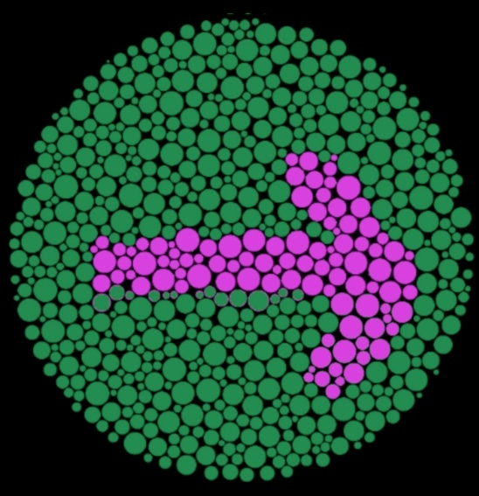
4:02 | The direction of the arrow in sign | Point MMS in the direction of the arrow | The arrow is pointing down at 4:02 | 
4:06 | The direction of the arrow in sign | Point MMS in the direction of the arrow | The arrow is pointing up at 4:06 | 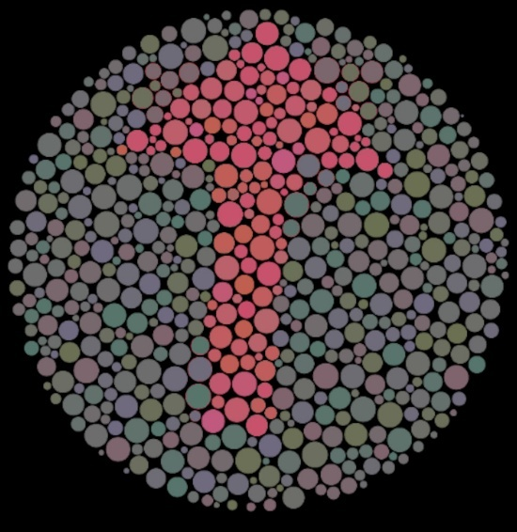
4:10 | The direction of the arrow in sign | Point MMS in the direction of the arrow | The arrow is pointing to the right at 4:10 | 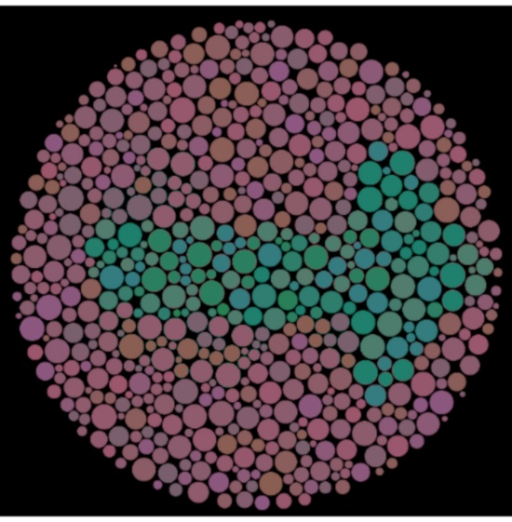
4:14 | The direction of the arrow in sign | Point MMS in the direction of the arrow | The arrow is pointing down at 4:14 | 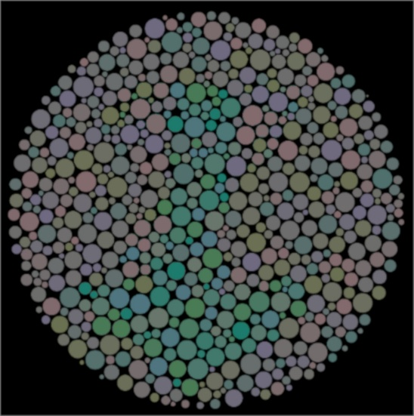
4:18 | The direction of the arrow in sign | Point MMS in the direction of the arrow | The arrow is pointing to the left at 4:18 | 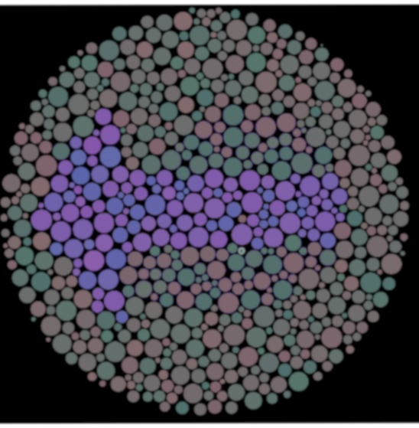
4:22 | The direction of the arrow in sign | Point MMS in the direction of the arrow | The arrow is pointing to the left at 4:22 | 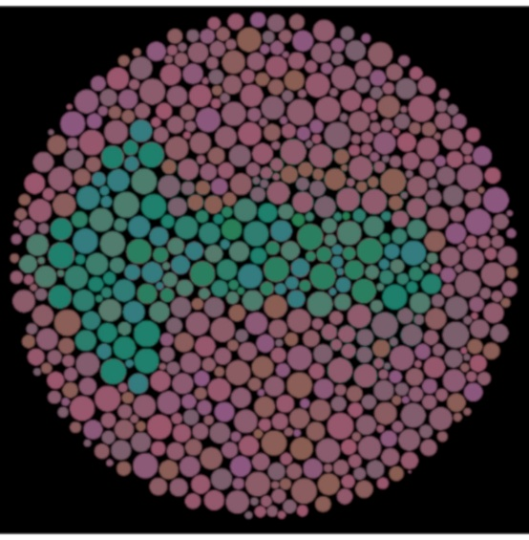
4:26 | The direction of the arrow in sign | Point MMS in the direction of the arrow | The arrow is pointing to the right at 4:26 | 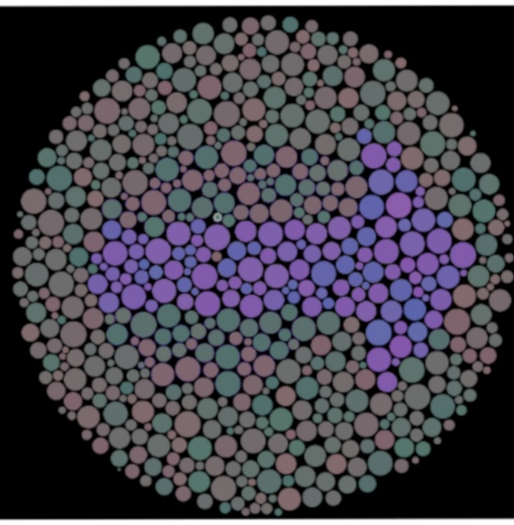
4:30 | The direction of the arrow in sign | Point MMS in the direction of the arrow | The arrow is pointing to the left at 4:30 | 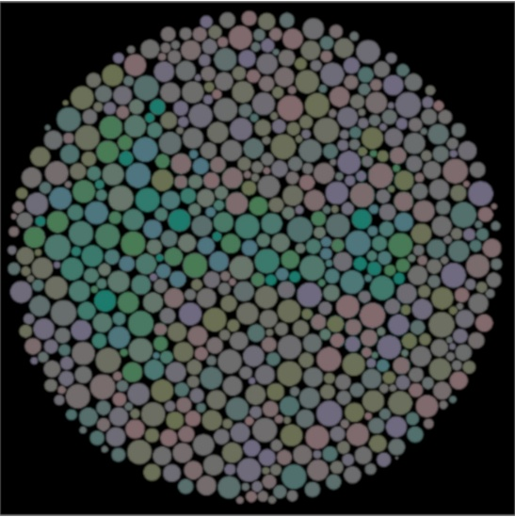
4:34 | The direction of the arrow in sign | Point MMS in the direction of the arrow | The arrow is pointing to the right at 4:34 | 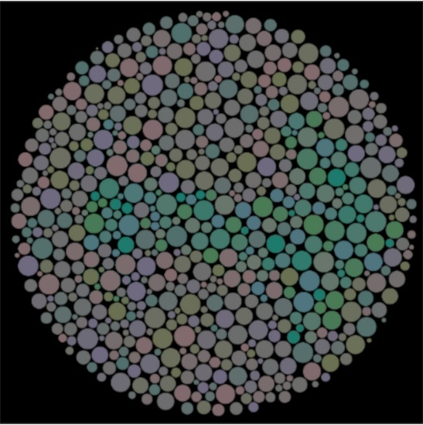
4:38 | The direction of the arrow in sign | Point MMS in the direction of the arrow | The arrow is pointing up at 4:38 | 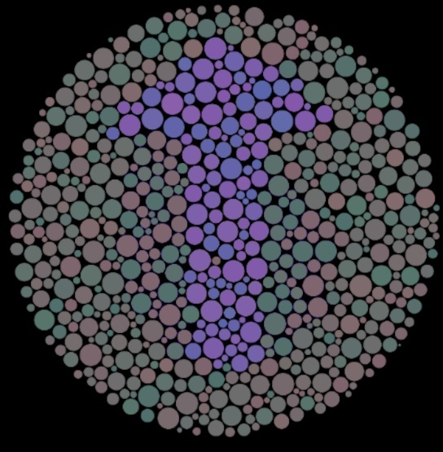
4:42 | The direction of the arrow in sign | Point MMS in the direction of the arrow | The arrow is pointing up at 4:42 | 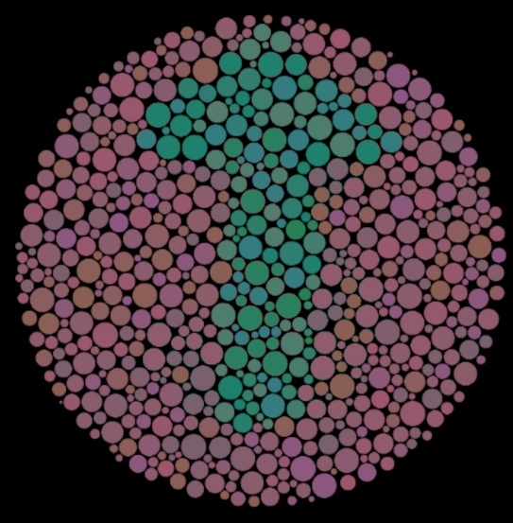
4:46 | The direction of the arrow in sign | Point MMS in the direction of the arrow | The arrow is pointing down at 4:46 | 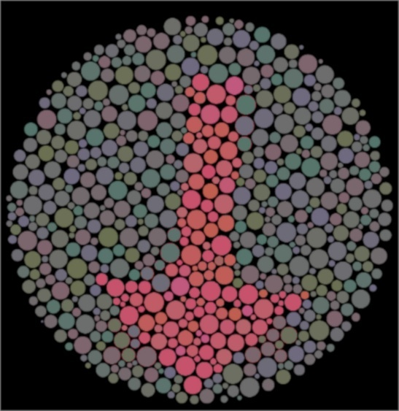
4:50 | The direction of the arrow in sign | Point MMS in the direction of the arrow | The arrow is pointing to the left at 4:50 | 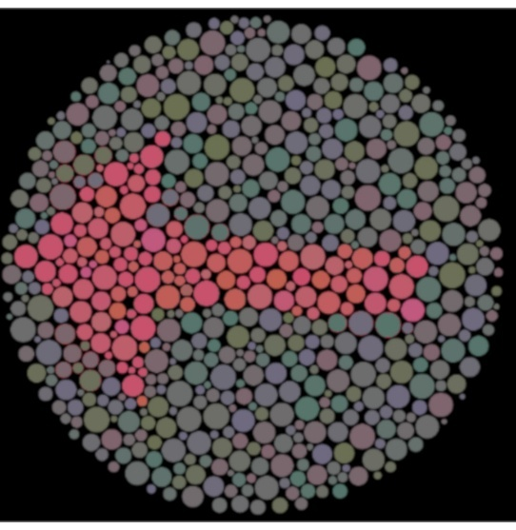
4:54 | The direction of the arrow in sign | Point MMS in the direction of the arrow | The arrow is pointing up at 4:54 | 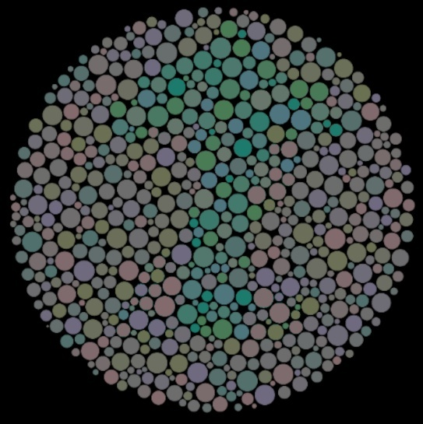
4:58 | The direction of the arrow in sign | Point MMS in the direction of the arrow | The arrow is pointing up at 4:58 | 
5:02 | The direction of the arrow in sign | Point MMS in the direction of the arrow | The arrow is pointing up at 5:02 | 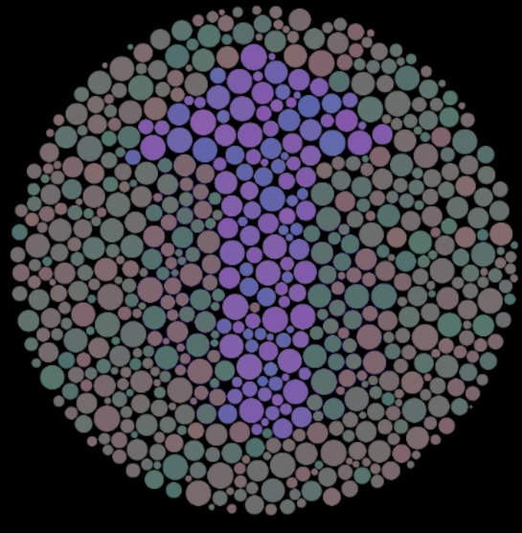
5:06 | The direction of the arrow in sign | Point MMS in the direction of the arrow | The arrow is pointing to the right at 5:06 | 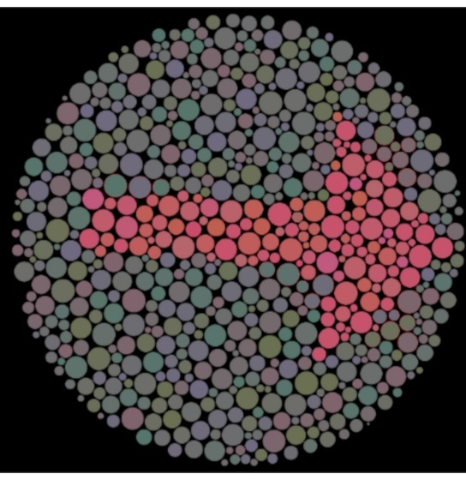
*The results will be presented as a plot. It may be easier to look at the gyro meter deflection to determine the direction of pointing.
Difficulty in distinguishing colours or experiencing partial colour vision deficiency affects approximately 1 in 15 children.

Conclusion
In conclusion, the colour recognition and separation activity presented in this document offers a fun and engaging way for children to learn and identify different colours. By using the magic monkey sticks and participating in interactive tasks, children can enhance their visual perception, attention to detail, and hand-eye coordination. Additionally, the activity encourages critical thinking and following instructions, which are essential skills for their overall development. The inclusion of tasks to identify embedded arrows in signs also helps in assessing potential colour vision impairments, providing valuable insights for further learning support. Overall, this activity not only promotes cognitive and motor skills but also boosts confidence and social interaction among children, making it a valuable addition to early childhood education.

